A MODEL FOR LYSOGENY WITHIN P.H.A.G.E.S.

A model of lysogeny using the key variables in figure 1 will be made to understand how oxygen and sugars influence viral infection strategies. A lysogeny model under P.H.A.G.E.S will be able to predict how biochemical conditions influence viral infection strategies. This model will have three pools corresponding to the three state variables: Sensitive Bacteria (S), Lysogens (L), and Viruses or Phages (V) (see Fig. 1). The pools will be connected by functions that mimic the main interactions described in P.H.A.G.E.S.: Expansion (E), Predation (P), and Assembly (A).

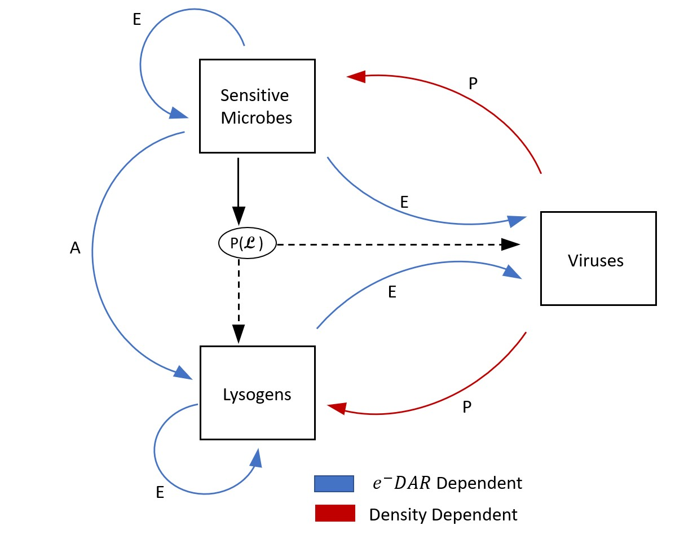

***Figure 1. Conceptual model of lysogeny*** *Sensitive microbes have the decision to go into the virulent or temperate phase based on the probability of lysogeny.*

The replication of S, L, and V are Expansion functions, the lytic infection of S by V is an example of a Predation function, and the lysogenic infection is an Assembly function. Two types of mechanisms control the functions: density dependence and the electron Donor-to-Acceptor Ratio (e-DAR=Sugar/Oxygen) (Fig. 2). The e-DAR defines the dominant type of metabolism in the system, with high values corresponding to anabolic metabolism, and low values to catabolic metabolism. The probability of lysogeny and replication will be controlled by the e-DAR because lysogeny is more prevalent in anabolic environments. 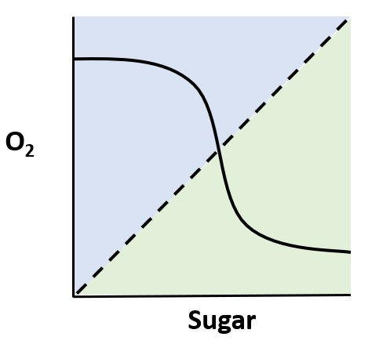

**Figure 2.** ***Relationship between oxygen and sugar.*** *The light green area represents anabolic conditions and the light blue area represents catabolic conditions. As sugar increases, oxygen decreases. Dotted line represent perfect conditions with a 1:1 ratio of oxygen and sugar, also known as the “goldilock’s line”.*

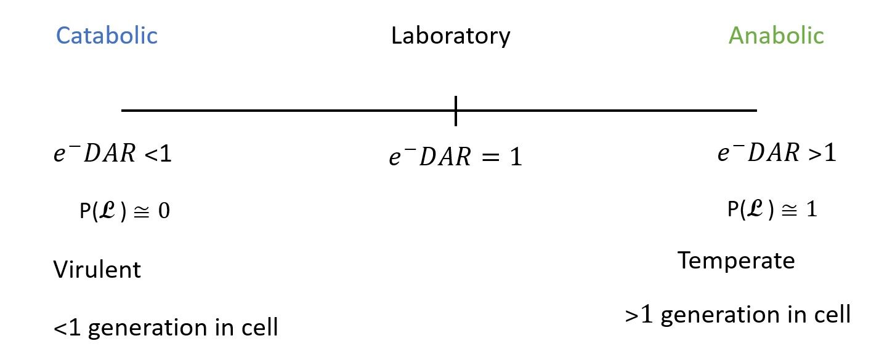

**Figure 3.** ***Model inputs and parameters.*** *Three conditions are described within four parameters: $e^{-}$ DAR, probability of lysogeny, viral infection strategies and time in cell.*

To test our hypothesis that metabolism drives the lysogenic-lytic switch via e-DAR, three scenarios will be considered (Fig.3): an e-DAR smaller than one, larger than one, and equal to one. The length of time a phage is inside a cell compared to the cell generation time will be considered in this model. Phages inside a cell longer than one generation is indicative of lysogeny and is associated with anabolic conditions. Consistent with our hypotheses, a large concentration of lysogens in the anabolic scenario and a low concentration of phages is expected (see Fig. 4). Because the concentration of phages will be low, predation will be less frequent (density-dependent) and sensitive microbes will be able to replicate faster. In the catabolic regime, the opposite is predicted: lysogeny will be very unlikely, whereas the concentration of phages will increase very quickly, and the concentration of sensitive bacteria will decrease. Depending on the specific values of the parameters, we might find extinction of all three biological agents.

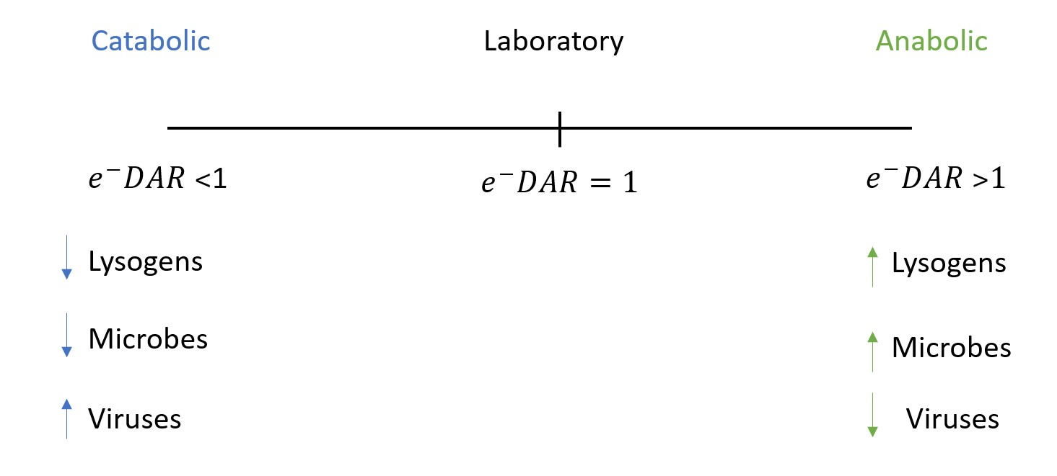

***Fig. 4. Expected results.*** *Under these three conditions, we expect to see the change of key variables as follows.*